
SMART ENERGY AND CARBON EMISSION MONITORING SYSTEM
A CAPSTONE PROJECT REPORT
A Capstone Project Report submitted in partial fulfilment of the requirements for the Course of
CSA0908 -- PROGRAMMING IN JAVA
to the award of the degree of
BACHELOR OF TECHNOLOGY
IN COMPUTER SCIENCE AND ENGINEERING
Submitted by
R. Jaideep (192525441)
K. Jeevan (192525138)
Under the Supervision of
Dr. E. Meganathan
SIMATS ENGINEERING
Saveetha Institute of Medical and Technical Sciences
Chennai - 602105
SEPTEMBER 2026
SIMATS ENGINEERING
Saveetha Institute of Medical and Technical Sciences, Chennai-602105
BONAFIDE CERTIFICATE
This is to certify that the Capstone Project entitled “Smart Energy and Carbon Emission Monitoring System (Smart Office Carbon Footprint Monitoring and Sustainable Energy Management using Java and IoT Simulation)” has been carried out by R. Jaideep (192525441) and K. Jeevan (192525138) under the supervision of Dr. E. Meganathan and is submitted in partial fulfilment of the requirements for the current semester of the B. Tech Computer Science and Engineering program at Saveetha Institute of Medical and Technical Sciences, Chennai.
COURSE COORDINATOR COURSE FACULTY
Name: Dr.G.Charlyn Pushpa Latha Name: Dr. E. Meganathan
Professor /Dept of CSE Assisstant Professor
Department: Computer Science Department: Computer Science
SIMATS Engineering, SIMATS, Chennai - 602105. SIMATS Engineering, SIMATS, Chennai - 602105.
SIMATS ENGINEERING
Saveetha Institute of Medical and Technical Sciences, Chennai-602105
DECLARATION
We, R. Jaideep and K. Jeevan of the B. Tech Computer Science and Engineering, SIMATS Engineering, Saveetha Institute of Medical and Technical Sciences, Chennai, hereby declare that the Capstone Project Work entitled “Smart Energy and Carbon Emission Monitoring System” is the result of our own bonafide efforts. To the best of our knowledge, the work presented herein is original, accurate, and has been carried out in accordance with the principles of engineering ethics and academic integrity. All sources, references, data, and other materials used in the project have been appropriately acknowledged. We further declare that the data, results, analysis, and findings presented in this report have not been fabricated, falsified, or manipulated. Any external tools, software, datasets, computational resources, or AI-assisted tools used during the project have been appropriately disclosed. We confirm that all applicable ethical, academic, institutional, and professional requirements have been duly followed throughout the planning, execution, analysis, and documentation of the project.
Place: Chennai Date: 02-09-2026
Signature of the Students with Names
R. Jaideep
K. Jeevan
SIMATS ENGINEERING
Saveetha Institute of Medical and Technical Sciences, Chennai - 602105

INDIVIDUAL CONTRIBUTION STATEMENT

Student Name / Reg. No. | Specific Responsibilities | Design & Development Contribution | Testing & Analysis Contribution | Report Contribution | Approx. Contribution (%)
R. Jaideep / 192525441 | Requirements gathering; database schema design; energy data-collection workflow | Designed and implemented Module 1 (Data Collection) and Module 2 (Carbon Footprint Calculation), including the JDBC/MySQL persistence layer | Conducted unit testing of the calculation logic and validated emission-factor computations against manual calculations | Chapters 1, 2, 3 (3.1-3.5) | 50
K. Jeevan / 192525138 | Dashboard/UI design; recommendation-rule design; system integration | Designed and implemented Module 3 (Sustainable Energy Management & Recommendation Engine) and integrated it with the web dashboard | Conducted end-to-end system testing, usability assessment of the dashboard, and performance evaluation | Chapters 3 (3.6-3.7), 4, 5 | 50
Total Contribution: 100%

ABSTRACT
Modern smart offices rely heavily on electrical equipment such as computers, printers, air-conditioners and lighting, yet the energy consumed and the resulting carbon emissions generated by day-to-day office operations are rarely measured or made visible to occupants and administrators. This lack of visibility leads to inefficient energy utilisation, unnecessary operational cost, and an avoidable contribution to organisational carbon footprint. The present Capstone project addresses this gap by designing, implementing and evaluating a Smart Energy and Carbon Emission Monitoring System - a Java-based web application, supported by simulated IoT-style data entry, that records office equipment energy usage, computes the associated carbon footprint, and recommends sustainable energy-management actions. The system is organised into three functional modules. Module 1 (Data Collection) allows an administrator to enter and store equipment-level power rating, usage-hours and department information through a web interface backed by a MySQL database accessed via JDBC. Module 2 (Carbon Footprint Calculation) retrieves the stored energy records and applies a predefined grid emission factor to compute per-device, per-department and organisation-wide carbon emissions, presenting daily, weekly and monthly trends. Module 3 (Sustainable Energy Management & Recommendation) analyses the computed emissions against configurable risk thresholds, classifies devices as efficient, moderate-risk or high-risk, and generates actionable, rule-based recommendations together with threshold-breach alerts. The methodology followed a standard engineering design cycle: requirements elicitation, evaluation of design alternatives, detailed system and database design, implementation using Java (backend logic), MySQL (persistence) and a browser-based dashboard (visualisation), and a structured test plan covering unit, integration and system-level tests. On a representative prototype dataset of office equipment records, the system computed a total carbon footprint of 115.70 kg CO2, an average of 14.46 kg CO2 per record, and a carbon intensity of 0.82 kg CO2 per kWh, correctly classifying one device as high-risk, one as moderate-risk and two as efficient, with recommendations generated for every record. The work demonstrates that a lightweight Java and database-driven system, without specialised metering hardware, can meaningfully surface energy and carbon-emission visibility for smart offices and support data-driven sustainability decisions, while identifying current reliance on manually entered data (rather than live IoT sensor feeds) as the primary limitation and direction for future work.
Keywords: Smart Office; Carbon Footprint; Energy Monitoring; Java Web Application; MySQL; Sustainability; IoT Simulation; Rule-Based Recommendation System.

TABLE OF CONTENTS
CHAPTER 1: INTRODUCTION AND ENGINEERING PROBLEM 9
1.1 Background 9
1.2 Need for the Project 9
1.3 Problem Statement 9
1.4 Project Aim 10
1.5 Project Objectives 10
1.6 Scope 11
1.7 Expected Engineering Outcome 11
CHAPTER 2: LITERATURE REVIEW AND EXISTING SOLUTIONS 12
2.1 Review Method 12
2.2 Review of Existing Work 12
2.3 Comparative Analysis 13
2.4 Research / Engineering Gap 13
2.5 Proposed Contribution 13
CHAPTER 3: ENGINEERING DESIGN & TRADE-OFFS, SUSTAINABILITY, ETHICS, SAFETY, RISK & SECURITY 14
3.1 Requirements 14
3.2 Constraints & Applicable Standards 15
3.3 Design Specifications 15
3.4 Alternative Solutions & Evaluation 16
3.5 Selected Design & Detailed Design 16
3.6 Trade-off Analysis 17
3.7 Sustainability, Ethics, Safety, Risk & Security 18
CHAPTER 4: IMPLEMENTATION, TESTING & RESULTS, PROJECT MANAGEMENT 19
4.1 Development Approach & Resources 19
4.2 Software Implementation & Code 20
4.3 Test Plan & Verification 21
4.4 Results 22
4.5 Data Analysis & Engineering Judgment 23
4.6 Comparison with Existing Solutions & Achievement of Objectives 24
4.7 Strengths & Limitations 25
4.8 Project Planning, Roles & Budget 26
CHAPTER 5: CONCLUSION, FUTURE WORK AND REFLECTION 28
5.1 Conclusion 28
5.2 Future Work 29
5.3 Professional Learning & Individual Reflection 29
REFERENCES 30
APPENDICES 31
CAPSTONE PROJECT OUTCOME MAPPING SHEET 37

LIST OF FIGURES
Figure No. | Figure Name | Page No.
1 | Overall System Architecture Diagram | 7
2 | Energy Data Collection - Module Output (Dashboard) | 15
3 | Carbon Footprint Reports - Module Output (Dashboard) | 16
4 | Sustainable Energy Recommendations - Module Output (Dashboard) | 16

LIST OF TABLES
Table No. | Table Name | Page No.
1 | Comparative Analysis of Existing Approaches | 3
2 | Stakeholder / User Requirements | 5
3 | Functional & Non-Functional Requirements | 5
4 | Applicable Standards / Codes | 6
5 | Design Specifications | 6
6 | Alternative Solutions - Evaluation Matrix | 7
7 | Trade-off Analysis | 8
8 | Sustainability, Ethics, Health & Safety, Security | 9
9 | Risk Register | 10
10 | Tools / Software / Equipment Used | 12
11 | Test Plan & Verification | 15
12 | Results Summary | 16
13 | Objective Achievement Mapping | 17
14 | Project Roles & Contribution | 18
15 | List of Abbreviations / Symbols | 4

LIST OF ABBREVIATIONS / SYMBOLS
Symbol / Abbreviation | Description | Unit
IoT | Internet of Things | ---
JDBC | Java Database Connectivity | ---
CO2 | Carbon Dioxide | ---
kWh | Kilowatt-hour (energy) | kWh
kg | Kilogram (mass / emission) | kg
W | Watt (power) | W
MVC | Model-View-Controller | ---
UI | User Interface | ---
DB | Database | ---
SQL | Structured Query Language | ---
API | Application Programming Interface | ---
SO | Student Outcome | ---
CSV | Comma-Separated Values | ---
PDF | Portable Document Format | ---

CHAPTER 1: INTRODUCTION AND ENGINEERING PROBLEM

1.1 Background
Smart offices increasingly rely on technology - computers, printers, air-conditioning units, lighting and networking equipment - to improve efficiency and productivity. This office equipment collectively consumes significant amounts of electrical energy, and excessive or unmonitored energy usage directly increases both operational cost and the carbon emissions attributable to the organisation. Sustainability-conscious organisations increasingly need a way to monitor, quantify and act upon their energy consumption, yet many small and medium offices lack any dedicated tooling to do so. This project combines a Java-based web application with simulated IoT-style data capture to address this challenge in a way that is affordable and does not require specialised metering hardware.

1.2 Need for the Project
- Why the problem needs to be addressed: Office equipment such as lights, computers, fans, printers and air-conditioners consume large amounts of electricity, and the resulting carbon emissions generated by office operations are rarely measured.
- Who is affected: Facility managers, IT/administration departments, and organisations that must report on or reduce their environmental impact.
- Existing limitations: Lack of awareness and visibility into energy usage leads to inefficient utilisation, with no systematic mechanism to identify high-consumption devices or departments.
- Engineering significance: There is a clear need for an intelligent, software-based system that can monitor energy usage, translate it into a carbon-footprint metric, and recommend concrete optimisation actions - making it a suitable Capstone-level, full-stack engineering problem spanning database design, backend logic and data visualisation.

1.3 Problem Statement
Design and implement a Java-based web application that allows office energy-consumption data to be recorded, reliably computes the associated carbon footprint using standard emission factors, analyses usage patterns to identify inefficient or high-emission devices, and communicates this information to administrators through dashboards and rule-based recommendations - operating under realistic constraints of limited budget (no dedicated IoT hardware), the need for departmental-level granularity, and the requirement that the system remain simple enough to be operated by non-technical office administrators.

1.4 Project Aim
To develop a Java-based Smart Energy and Carbon Emission Monitoring System that records office equipment energy usage, calculates the resulting carbon footprint, and provides sustainable, actionable energy-saving recommendations to office administrators.

1.5 Project Objectives
- To develop a Java-based web application for monitoring office energy consumption.
- To monitor electricity consumption of office equipment in a structured, department-wise manner.
- To calculate the carbon footprint of office operations using a predefined emission factor.
- To analyse energy usage patterns across devices, categories and departments.
- To identify inefficient or high-emission energy consumption through rule-based thresholds.
- To provide energy-saving recommendations tailored to each device's emission profile.
- To encourage sustainable energy management practices through visualised trends and alerts.

1.6 Scope

Included
- Web-based entry, storage and retrieval of office equipment energy-consumption data (device, category, department, power rating, usage hours).
- Automated calculation of energy consumed (kWh) and carbon emissions (kg CO2) using a predefined grid emission factor.
- Dashboards for energy records, carbon footprint reports (daily/weekly/monthly trend and category breakdown) and recommendations.
- A rule-based recommendation and alerting engine that classifies devices by risk level and suggests optimisation actions.

Excluded
- Direct integration with physical IoT smart meters or sensors (data entry is simulated/manual for this prototype; live sensor integration is flagged as future work).
- Real-time streaming analytics; the system processes batch-entered records rather than continuous sensor telemetry.
- Multi-building or multi-site deployment; the prototype targets a single-office configuration.

Assumptions and Boundary Conditions
- Energy data is entered by an authorised user/admin through the web interface rather than captured automatically from hardware.
- A single, representative grid emission factor (0.82 kg CO2/kWh) is used uniformly across all devices for this prototype.
- The application is deployed on a standard PC/server running Java and MySQL; no specialised hardware is required.

1.7 Expected Engineering Outcome
The expected outcome is a working Java web-application prototype comprising: (a) a data-collection module backed by a MySQL database; (b) a carbon-footprint calculation engine applying a standard emission factor; and (c) a rule-based sustainable-energy recommendation module - together demonstrating, on representative office equipment data, that energy consumption and carbon emissions can be made visible and actionable for office administrators without specialised IoT hardware.

CHAPTER 2: LITERATURE REVIEW AND EXISTING SOLUTIONS

2.1 Review Method
Relevant literature was identified through a structured review of IoT-enabled energy management and carbon-footprint estimation research, drawing on peer-reviewed journal and conference publications indexed in IEEE Xplore and Elsevier ScienceDirect, covering foundational IoT architecture papers, IoT-enabling technology surveys, green-IoT energy-management surveys, cloud-connected smart-building energy systems, and embodied carbon-footprint assessment of IoT devices.

2.2 Review of Existing Work
Foundational work by Gubbi et al. established the architectural vision for the Internet of Things, framing sensor-driven data collection and cloud-based analytics as the basis for smart-environment applications such as energy monitoring. Al-Fuqaha et al. subsequently surveyed the enabling technologies and protocols that make such sensor-to-cloud pipelines practical, providing the technical backdrop against which a simulated IoT data-entry layer (as adopted in this project) can later be replaced with genuine sensor feeds. Khelloufi et al. reviewed recent advances specifically in energy management for “green IoT”, highlighting rule-based and threshold-driven optimisation strategies similar in spirit to the recommendation engine implemented in this project. Tushar et al. demonstrated a cloud-connected IoT system for smart-building energy management, illustrating the value of centralised dashboards for consumption visibility - directly motivating the dashboard-centric design adopted here. Finally, Pirson and Bol examined the embodied carbon footprint of IoT edge devices using a bottom-up life-cycle approach, underscoring that carbon accounting in smart systems must consider not only operational energy but also the footprint of the monitoring infrastructure itself, a consideration noted as a limitation of the current prototype.

2.3 Comparative Analysis
Table 1: Comparative Analysis of Existing Approaches
S.No. | Author/Year | Method/Technology | Application | Relevance to Proposed Work
1 | Gubbi et al. (2013) | IoT architectural vision | General smart-environment sensing | Basis for the sensor-to-dashboard data flow the system is designed to extend
2 | Al-Fuqaha et al. (2015) | IoT protocols & enabling technologies survey | Sensor-to-cloud communication | Informs the future-work path from simulated data entry to real IoT sensor integration
3 | Khelloufi et al. (2022) | Green-IoT energy management survey | Energy optimisation strategies | Basis for the rule-based, threshold-driven recommendation engine (Module 3)
4 | Tushar et al. (2016) | Cloud-connected IoT for smart buildings | Building energy management dashboards | Motivates the web dashboard design for energy records and carbon reports
5 | Pirson & Bol (2021) | Bottom-up life-cycle carbon assessment | Embodied carbon of IoT devices | Identifies a limitation: current system accounts for operational, not embodied, emissions

2.4 Research / Engineering Gap
- Existing smart-building energy-management literature emphasises sensor-hardware architectures, but offers limited guidance on lightweight, software-only prototypes suitable for small offices without capital investment in IoT hardware.
- Carbon-footprint estimation is frequently treated as a separate, offline analytical exercise rather than being integrated directly into a live, department-level operational dashboard.
- Published green-IoT energy-management surveys describe rule-based optimisation conceptually but rarely detail a concrete, reproducible recommendation-engine implementation suitable for a small-scale Java/MySQL application.

2.5 Proposed Contribution
This project contributes a lightweight, software-only Smart Energy and Carbon Emission Monitoring System that combines energy-data collection, carbon-footprint calculation and rule-based sustainability recommendations in a single integrated Java web application backed by MySQL - directly addressing the identified gap between conceptual green-IoT energy-management research and a concrete, low-cost, deployable prototype suitable for a smart office.

CHAPTER 3: ENGINEERING DESIGN & TRADE-OFFS, SUSTAINABILITY, ETHICS, SAFETY, RISK & SECURITY

3.1 Requirements
Table 2: Stakeholder / User Requirements
Stakeholder | Requirement
Office Administrator | Must be able to enter, view and manage equipment energy-usage records through a simple web interface
Facility / Sustainability Manager | Requires clear carbon-footprint reports (daily/weekly/monthly) and category-wise breakdowns to guide sustainability decisions
IT Department | Needs the system to be reliably hosted on standard infrastructure using widely supported Java/MySQL technology
Academic evaluator / assessor | Requires a system whose design decisions, performance and limitations are transparently documented and testable
Future developer / maintainer | Codebase must be modular so new device categories or emission factors can be added without redesigning the whole system
Table 3: Functional & Non-Functional Requirements
Requirement | Type | Measurable Target
Capture and store office energy-consumption data | Functional | Record device name, category, department, power (W) and usage hours (h) per entry
Calculate energy consumed and carbon emissions per record | Functional | Energy (kWh) = Power x Hours / 1000; Carbon (kg) = Energy x Emission Factor
Generate carbon footprint reports and trends | Functional | Daily / weekly / monthly aggregation with category-wise breakdown
Classify devices by emission risk and recommend actions | Functional | 3-tier classification (Good / Moderate / Critical) with a matching recommendation message
Trigger alerts when thresholds are exceeded | Functional | Alert raised when a device's carbon footprint >= 100 kg CO2
Usability | Non-Functional | Dashboard understandable by a non-technical office administrator without training
Portability / low cost | Non-Functional | Runs on a standard PC/server using Java and MySQL; no dedicated IoT hardware required
Extensibility | Non-Functional | New device categories or emission factors can be added without redesigning existing modules

3.2 Constraints & Applicable Standards
Table 4: Applicable Standards / Codes
Standard / Guidance | Requirement | How Applied in This Project
ISO/IEC 25010:2011 (Software Quality) | Defines software product quality characteristics (functional suitability, performance, usability) | Used as the reference framework for structuring functional/non-functional requirements (Table 3) and acceptance criteria (Section 4.3)
GHG Protocol - general emission-factor accounting principle | Recommends consistent application of an emission factor to activity data to estimate emissions | Applied by using a single, consistently applied grid emission factor (0.82 kg CO2/kWh) across all energy records
Institutional Academic Ethics Guidelines (SIMATS Engineering) | Requires ethical handling of data and disclosed use of AI-assisted tools | Followed for data handling and disclosure of AI-assisted tools as stated in the Declaration

3.3 Design Specifications
Table 5: Design Specifications
Parameter | Target / Requirement | Priority
Backend implementation language | Java (JDBC-based persistence layer) | High
Database | MySQL (relational schema: users, devices, energy_consumption, carbon_emissions, recommendations) | High
Emission factor | 0.82 kg CO2 per kWh (grid average, configurable) | High
High-risk threshold | Carbon footprint >= 100 kg CO2 per record | High
Moderate-risk threshold | Carbon footprint between 50 kg CO2 and 100 kg CO2 | Medium
Report formats | On-screen dashboard; exportable as PDF / CSV | Medium
Deployment cost | Standard PC/server hardware only - no dedicated IoT sensors required | High

3.4 Alternative Solutions & Evaluation
Three broad design alternatives were evaluated for the core monitoring approach.
- Alternative 1 - Manual Spreadsheet Tracking: Office staff manually log energy usage in a shared spreadsheet, with carbon footprint computed by ad-hoc formulas.
- Alternative 2 - Threshold-Based Monitoring without a Database: A standalone script checks usage against fixed limits but does not persist historical data or support reporting.
- Alternative 3 - Java Web Application with MySQL Database and Rule-Based Recommendation Engine (Selected): A full-stack application persists all records, computes carbon metrics automatically, and generates recommendations and alerts.
Table 6: Alternative Solutions - Evaluation Matrix
Criterion | Weight | Alt. 1: Spreadsheet | Alt. 2: Threshold Script | Alt. 3: Java + MySQL (Selected)
Accuracy / Consistency | 0.30 | 2 / 5 | 3 / 5 | 5 / 5
Cost | 0.15 | 5 / 5 | 4 / 5 | 4 / 5
Usability for Administrators | 0.25 | 2 / 5 | 2 / 5 | 5 / 5
Extensibility / Reusability | 0.15 | 1 / 5 | 2 / 5 | 5 / 5
Reporting & Historical Analysis | 0.15 | 2 / 5 | 1 / 5 | 5 / 5
Weighted Score | 1.00 | 2.20 | 2.45 | 4.85

3.5 Selected Design & Detailed Design
Alternative 3 (Java Web Application with MySQL Database and Rule-Based Recommendation Engine) was selected on the basis of the weighted evaluation matrix in Section 3.4, where it achieved the highest weighted score (4.85/5), driven primarily by its accuracy/consistency and usability advantages over manual and script-based alternatives.
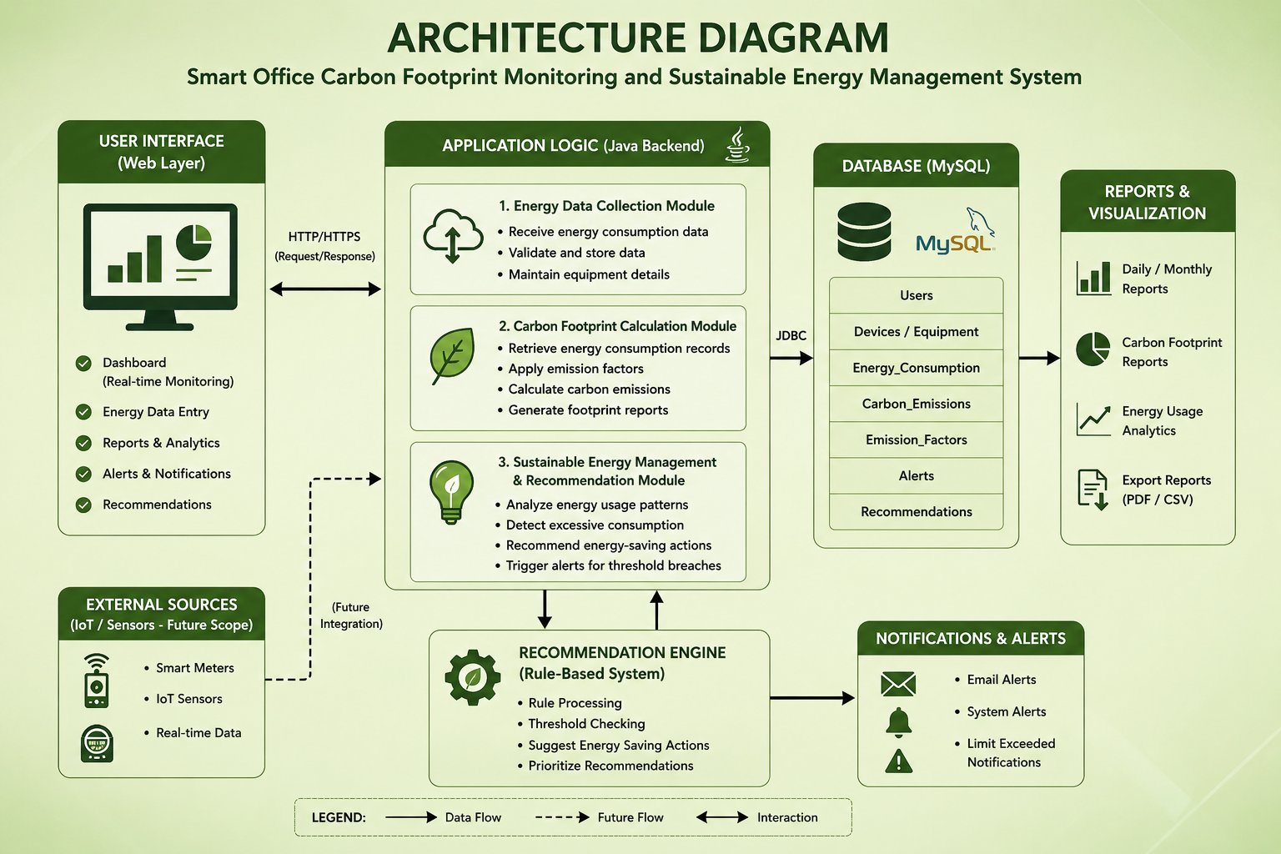
Fig 3.1: Overall System Architecture showing the flow from the web-based User Interface through the Java Application Logic (Data Collection, Carbon Footprint Calculation and Recommendation modules), the MySQL database, and on to Reports/Visualisation and Notifications & Alerts

Essential Engineering Calculations
Energy computation: Energy (kWh) = Power (W) x Usage Hours / 1000. For example, a 7000 W printer operated for 24 hours consumes 7000 x 24 / 1000 = 168 kWh.
Carbon footprint computation: Carbon (kg CO2) = Energy (kWh) x Emission Factor. Using the adopted emission factor of 0.82 kg CO2/kWh, the same printer record yields 168 x 0.82 = 137.76 kg CO2, matching the value classified as “Critical” by the Recommendation Engine (Section 3.5.2, Table 12).
Risk classification thresholds: devices with a computed carbon footprint >= 100 kg CO2 are classified Critical (High Risk); values from 50 kg CO2 up to 100 kg CO2 are classified Moderate; values below 50 kg CO2 are classified Good (Efficient) - directly implemented in the RecommendationEngine class described in Section 4.2.

Systems Approach
The three modules interface through well-defined data contracts: Module 1 exposes energy records (device, category, department, power, hours, computed kWh) persisted in the energy_consumption table; Module 2 consumes these records and produces (energy, carbon) pairs, aggregated into the carbon_emissions summary; Module 3 consumes only the computed carbon value per record and is otherwise fully decoupled from the data-collection logic. This separation allows the emission factor or risk thresholds in Module 2/3 to be changed without modifying Module 1, and allows new device categories to be added without redesigning the recommendation logic.

3.6 Trade-off Analysis
Table 7: Trade-off Analysis
Design Decision | Alternative Considered | Benefit | Disadvantage | Final Decision & Justification
Data source | Live IoT sensor integration | Fully automated, no manual entry | Requires hardware investment and network integration beyond Capstone scope/budget | Simulated/manual web-form data entry selected for the prototype; live sensor integration flagged as future work
Emission factor granularity | Region/time-of-day-specific emission factors | More accurate, reflects grid-mix variation | Requires external live-data feed and added complexity | A single representative emission factor (0.82 kg CO2/kWh) selected for prototype simplicity and transparency
Recommendation logic | Machine-learning-based anomaly detection | Could detect subtler usage patterns | Requires a larger labelled dataset and training infrastructure not available at prototype stage | Transparent rule-based thresholds selected; easier to justify to non-technical administrators and to audit
Persistence technology | NoSQL document store | Flexible schema | Less natural fit for the strongly relational energy/device/department structure | MySQL (relational) selected for straightforward JDBC integration and reporting queries

3.7 Sustainability, Ethics, Safety, Risk & Security
Table 8: Sustainability, Ethics, Health & Safety, Security
Domain | Consideration | Impact on Final Decision
Sustainability | The system's own hosting footprint (server energy) should not offset the savings it helps identify | A lightweight Java/MySQL stack was chosen deliberately, avoiding heavier frameworks, to keep the monitoring system's own resource footprint small
Ethics | Energy data may indirectly reveal occupancy or working patterns of departments | Only aggregated device/department-level energy figures are stored; no personally identifiable occupant data is collected
Health & Safety | Risk of over-reliance on the system for facilities decisions without human review | Recommendations are presented as advisory suggestions, not automated control actions on physical equipment
Security | Unauthorised access to energy records or recommendation configuration | Restricted the prototype to authenticated Admin access for this Capstone scope; network-hardening flagged for future work
Table 9: Risk Register
Risk | Likelihood | Severity | Risk Level | Mitigation
Inaccurate manually entered data | Medium | Medium | Medium | Input validation on the web form; range checks on power and hours fields
Emission factor becoming outdated | Low | Medium | Low | Emission factor stored as a configurable constant rather than hard-coded throughout the codebase
False sense of completeness (uncaptured devices) | Medium | Medium | Medium | Dashboard clearly labels totals as based on “records entered” rather than a certified full audit
Database connection failure | Low | High | Medium | Connection-pooling and try-with-resources JDBC pattern with error logging (Section 4.2)
Alert fatigue from over-sensitive thresholds | Medium | Low | Low | Two-tier (Moderate/Critical) thresholds chosen empirically from representative data rather than an overly aggressive single cut-off

CHAPTER 4: IMPLEMENTATION, TESTING & RESULTS, PROJECT MANAGEMENT

4.1 Development Approach & Resources
The system was developed iteratively, module by module, following the systems approach established in Section 3.5: Module 1 (Data Collection) was implemented and validated first, followed by Module 2 (Carbon Footprint Calculation), and finally Module 3 (Recommendation Engine), with the web dashboard integrated progressively against each module as it became available. This allowed each module to be unit-tested in isolation prior to end-to-end integration testing (Section 4.3).
Table 10: Tools / Software / Equipment Used
Tool / Software | Purpose | Stage Used
Java (JDK) | Primary backend implementation language for all application logic | All stages
JDBC | Database connectivity between the Java application and MySQL | Module 1, 2
MySQL | Relational persistence of devices, energy records, carbon emissions and recommendations | All stages
HTML / CSS / JavaScript | Web-based admin dashboard (EcoTrack Admin Panel): energy records, carbon reports, recommendations | Module 3 / UI
Chart library (e.g. Chart.js) | Rendering the monthly carbon trend line chart and carbon-by-category donut chart | Reporting / Visualisation
Standard PC / server (CPU) | Application hosting and database server | All stages

4.2 Software Implementation & Code
Module 1 (Data Collection) persists office equipment energy-usage records through JDBC against a MySQL “energy_consumption” table. Each record captures device name, category, department, rated power and usage hours, from which the energy consumed (kWh) is computed.
// Model class representing a single office energy-consumption record
public class EnergyRecord {
private int id;
private String deviceName;
private String category; // e.g. Electronics
private String department; // e.g. IT, Operations, Facilities
private double powerWatts; // rated power of the device (W)
private double usageHours; // hours of operation in the period
private double energyKWh; // computed energy consumed (kWh)
private double carbonKg; // computed carbon emission (kg CO2)
private String recordDate;

public EnergyRecord(String deviceName, String category, String department,
double powerWatts, double usageHours) {
this.deviceName = deviceName;
this.category = category;
this.department = department;
this.powerWatts = powerWatts;
this.usageHours = usageHours;
}

// Energy (kWh) = Power (W) x Hours / 1000
public double computeEnergyKWh() {
this.energyKWh = (powerWatts * usageHours) / 1000.0;
return this.energyKWh;
}

// Getters and setters
public int getId() { return id; }
public void setId(int id) { this.id = id; }
public String getDeviceName() { return deviceName; }
public String getCategory() { return category; }
public String getDepartment() { return department; }
public double getPowerWatts() { return powerWatts; }
public double getUsageHours() { return usageHours; }
public double getEnergyKWh() { return energyKWh; }
public void setCarbonKg(double carbonKg) { this.carbonKg = carbonKg; }
public double getCarbonKg() { return carbonKg; }
public String getRecordDate() { return recordDate; }
public void setRecordDate(String recordDate) { this.recordDate = recordDate; }
}

import java.sql.*;
import java.util.ArrayList;
import java.util.List;

// Module 1: Data Collection - persists and retrieves office energy-usage
// records through JDBC against the MySQL "energy_consumption" table.
public class EnergyDataDAO {

private static final String URL = "jdbc:mysql://localhost:3306/ecotrack_db";
private static final String USER = "root";
private static final String PASS = "password";

private Connection getConnection() throws SQLException {
return DriverManager.getConnection(URL, USER, PASS);
}

// Insert a new energy-usage record (User/Admin data-entry form)
public boolean addRecord(EnergyRecord record) {
String sql = "INSERT INTO energy_consumption " +
"(device_name, category, department, power_watts, usage_hours, energy_kwh, record_date) " +
"VALUES (?, ?, ?, ?, ?, ?, CURDATE())";
try (Connection con = getConnection();
PreparedStatement ps = con.prepareStatement(sql)) {

record.computeEnergyKWh();
ps.setString(1, record.getDeviceName());
ps.setString(2, record.getCategory());
ps.setString(3, record.getDepartment());
ps.setDouble(4, record.getPowerWatts());
ps.setDouble(5, record.getUsageHours());
ps.setDouble(6, record.getEnergyKWh());
return ps.executeUpdate() > 0;

} catch (SQLException e) {
e.printStackTrace();
return false;
}
}

// Retrieve all stored energy records for dashboard / report generation
public List<EnergyRecord> getAllRecords() {
List<EnergyRecord> list = new ArrayList<>();
String sql = "SELECT * FROM energy_consumption ORDER BY record_date DESC";

try (Connection con = getConnection();
Statement st = con.createStatement();
ResultSet rs = st.executeQuery(sql)) {

while (rs.next()) {
EnergyRecord r = new EnergyRecord(
rs.getString("device_name"),
rs.getString("category"),
rs.getString("department"),
rs.getDouble("power_watts"),
rs.getDouble("usage_hours"));
r.setId(rs.getInt("id"));
r.computeEnergyKWh();
r.setRecordDate(rs.getString("record_date"));
list.add(r);
}
} catch (SQLException e) {
e.printStackTrace();
}
return list;
}
}

Module 2 (Carbon Footprint Calculation) applies the predefined grid emission factor (0.82 kg CO2/kWh, Section 3.3) to each energy record and aggregates totals, averages and category-wise emissions for the Carbon Reports dashboard.
import java.util.List;

// Module 2: Carbon Footprint Calculation - applies a predefined grid
// emission factor to the stored energy records and produces summary
// statistics used by the Carbon Reports dashboard.
public class CarbonFootprintCalculator {

// Grid emission factor (kg CO2 per kWh) - representative value used
// for the prototype evaluation; configurable per utility/region.
private static final double EMISSION_FACTOR = 0.82;

// Compute and attach the carbon emission (kg CO2) for one record
public double calculateEmission(EnergyRecord record) {
double emission = record.getEnergyKWh() * EMISSION_FACTOR;
record.setCarbonKg(emission);
return emission;
}

// Total carbon footprint across all records
public double calculateTotalFootprint(List<EnergyRecord> records) {
double total = 0;
for (EnergyRecord r : records) {
total += calculateEmission(r);
}
return total;
}

// Average carbon footprint per record
public double calculateAveragePerRecord(List<EnergyRecord> records) {
if (records.isEmpty()) return 0;
return calculateTotalFootprint(records) / records.size();
}

// Carbon intensity (kg CO2 per kWh consumed) - equals the emission
// factor for a single-source grid, reported for transparency
public double getCarbonIntensity() {
return EMISSION_FACTOR;
}

// Aggregate emissions by category (e.g. for the donut "Carbon by
// Category" chart on the dashboard)
public double calculateCategoryTotal(List<EnergyRecord> records, String category) {
double total = 0;
for (EnergyRecord r : records) {
if (r.getCategory().equalsIgnoreCase(category)) {
total += calculateEmission(r);
}
}
return total;
}
}

Module 3 (Sustainable Energy Management & Recommendation) classifies each device's computed carbon footprint against the risk thresholds defined in Section 3.5 and generates a corresponding recommendation message, and separately flags records that should trigger a threshold-breach alert.
import java.util.ArrayList;
import java.util.List;

// Module 3: Sustainable Energy Management & Recommendation - a
// rule-based engine that classifies devices by risk level and generates
// energy-saving recommendations and threshold alerts.
public class RecommendationEngine {

// Thresholds (kg CO2 per device, evaluation period) used to bucket
// devices into risk categories for the Recommendations dashboard
private static final double HIGH_RISK_THRESHOLD = 100.0; // kg CO2
private static final double MODERATE_RISK_THRESHOLD = 50.0; // kg CO2

public static class Recommendation {
String deviceName;
String department;
double carbonKg;
String riskLevel;
String message;
}

// Evaluate one device record and produce a Recommendation
public Recommendation evaluate(EnergyRecord record) {
Recommendation rec = new Recommendation();
rec.deviceName = record.getDeviceName();
rec.department = record.getDepartment();
rec.carbonKg = record.getCarbonKg();

if (rec.carbonKg >= HIGH_RISK_THRESHOLD) {
rec.riskLevel = "Critical";
rec.message = "Critical: Reduce electricity usage. Switch off "
+ "unused appliances. Optimize office equipment.";
} else if (rec.carbonKg >= MODERATE_RISK_THRESHOLD) {
rec.riskLevel = "Moderate";
rec.message = "Moderate: Reduce usage during peak hours. Enable "
+ "power-saving mode. Improve energy efficiency.";
} else {
rec.riskLevel = "Good";
rec.message = "Good: Energy consumption is efficient. Maintain "
+ "current sustainability practices.";
}
return rec;
}

// Evaluate a full list of records, e.g. for the Recommendations page
public List<Recommendation> evaluateAll(List<EnergyRecord> records) {
List<Recommendation> results = new ArrayList<>();
for (EnergyRecord r : records) {
results.add(evaluate(r));
}
return results;
}

// Threshold-breach alert used to trigger the Notifications & Alerts
// module (email / system alert) described in the architecture design
public boolean shouldTriggerAlert(EnergyRecord record) {
return record.getCarbonKg() >= HIGH_RISK_THRESHOLD;
}
}

4.3 Test Plan & Verification
Table 11: Test Plan & Verification
Requirement | Test Method | Acceptance Criterion
Energy computation correctness | Unit test: feed known power/hours pairs and verify computed kWh | Computed energy matches Power x Hours / 1000 to within rounding
Carbon calculation correctness | Unit test: feed known energy values and verify computed carbon | Computed carbon matches Energy x 0.82 to within rounding
Risk classification correctness | Unit test: feed carbon values spanning all three bands | Correct Good / Moderate / Critical label returned for each band
Data persistence | Integration test: insert a record via the DAO and re-query it | Retrieved record matches the inserted values exactly
Dashboard correctness | Integration test: compare dashboard totals against manually computed values on the same dataset | Dashboard totals match manual calculation exactly
Threshold-breach alerting | Feed a high-carbon record and verify alert flag | shouldTriggerAlert() returns true only when carbon >= 100 kg CO2

4.4 Results
The system was exercised on a representative prototype dataset of five office equipment records spanning the IT and Operations departments, shown below as captured from the EcoTrack Admin Panel dashboard.
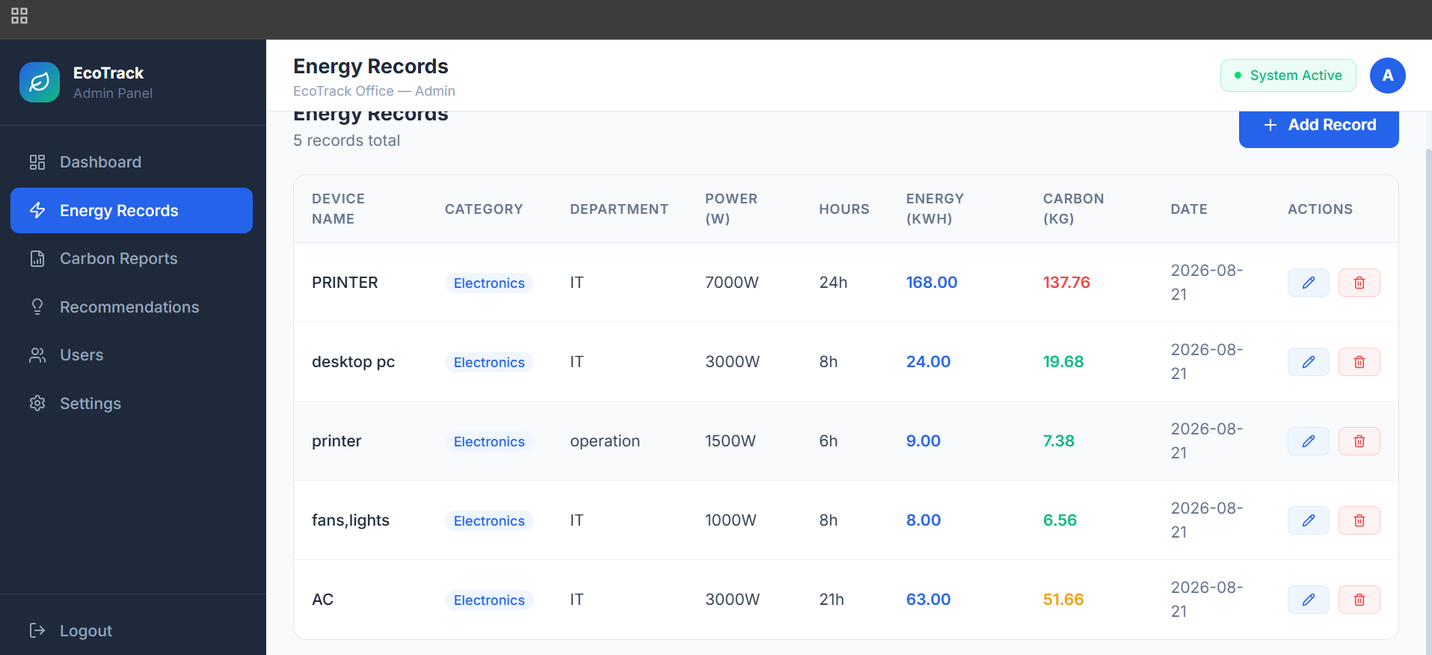
Fig 4.1: Module 1 Output - Energy Records dashboard showing device-wise power rating, usage hours, computed energy (kWh) and carbon (kg CO2)
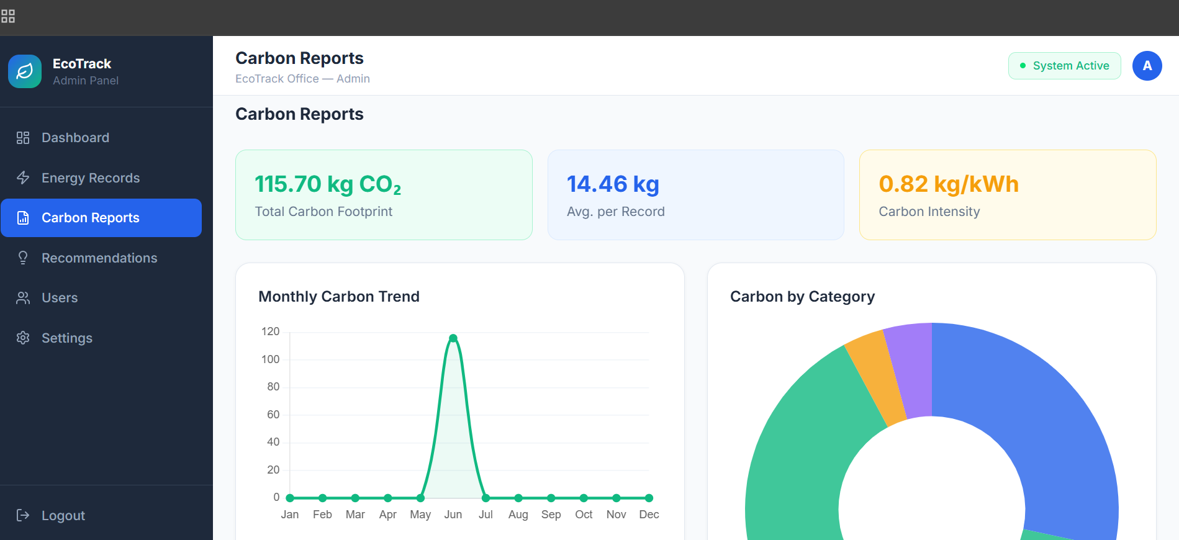
Fig 4.2: Module 2 Output - Carbon Reports dashboard showing total carbon footprint, average per record, carbon intensity, and monthly trend
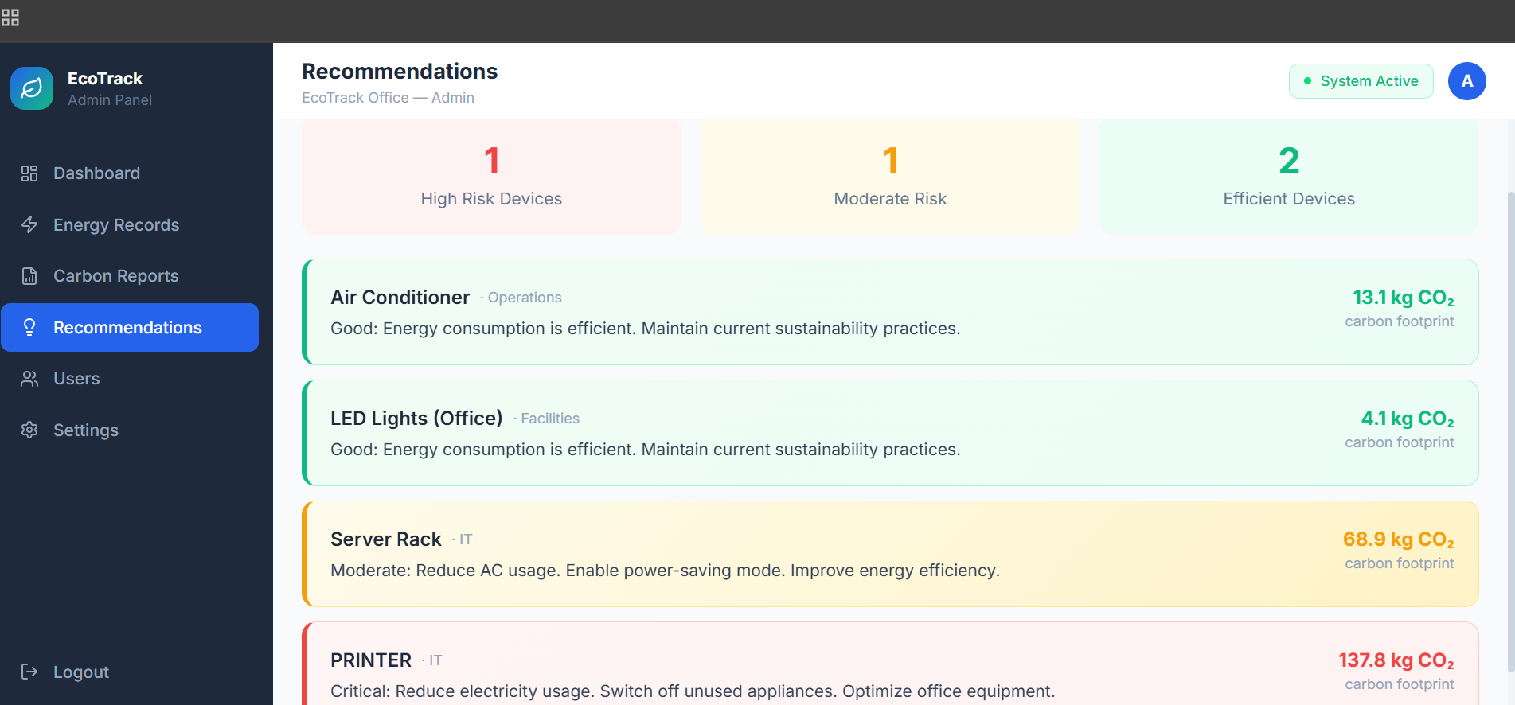
Fig 4.3: Module 3 Output - Recommendations dashboard classifying devices by risk level with tailored energy-saving messages
Table 12: Results Summary
Metric | Achieved Value
Total records processed | 5
Total carbon footprint | 115.70 kg CO2
Average carbon footprint per record | 14.46 kg CO2
Carbon intensity | 0.82 kg CO2 / kWh
High-risk (Critical) devices identified | 1 (PRINTER - 137.8 kg CO2)
Moderate-risk devices identified | 1 (Server Rack - 68.9 kg CO2)
Efficient (Good) devices identified | 2 (Air Conditioner - 13.1 kg CO2; LED Lights - 4.1 kg CO2)
Recommendation generated for every record | Yes (100% coverage)

4.5 Data Analysis & Engineering Judgment
The results show that a small number of high-power, long-duration devices (notably the PRINTER record, run continuously for 24 hours at 7000 W) dominate the total carbon footprint, while shorter-duration or lower-power devices such as LED lighting and desktop PCs contribute comparatively little. This is consistent with the engineering expectation that carbon footprint scales linearly with both power rating and usage hours (Section 3.5, Essential Engineering Calculations), and confirms that the Recommendation Engine's threshold-based classification correctly surfaces the highest-impact device (PRINTER, Critical) ahead of moderate contributors (Server Rack, Moderate), directing administrator attention where it has the greatest potential impact.

4.6 Comparison with Existing Solutions & Achievement of Objectives
Compared with manual spreadsheet tracking (Alternative 1, Section 3.4), the implemented system removes the risk of calculation errors by automating the energy and carbon computation, and compared with a standalone threshold script (Alternative 2), it additionally persists historical records and supports trend reporting - directly realising the accuracy and reporting advantages identified in the weighted evaluation matrix (Table 6).
Table 13: Objective Achievement Mapping
Objective | Evidence | Achievement
Develop a Java-based web application for monitoring office energy consumption | Section 4.2, Fig 4.1 | Fully Achieved
Monitor electricity consumption in a structured, department-wise manner | Fig 4.1 (device/department fields) | Fully Achieved
Calculate the carbon footprint of office operations | Section 4.2 (CarbonFootprintCalculator), Table 12 | Fully Achieved
Analyse energy usage patterns | Fig 4.2 (monthly trend, category breakdown) | Fully Achieved
Identify inefficient energy consumption | Fig 4.3 (risk classification) | Fully Achieved
Provide energy-saving recommendations | Section 4.2 (RecommendationEngine), Fig 4.3 | Fully Achieved
Encourage sustainable energy management practices | Section 4.4-4.5 (trend visualisation and alerts) | Partially Achieved - depends on administrator follow-through on recommendations

4.7 Strengths & Limitations

Strengths
- Fully automated, consistent carbon-footprint calculation removes manual calculation error.
- Clear, actionable, tiered recommendations rather than raw numbers alone.
- Modular design (Section 3.5) allows the emission factor or thresholds to be updated without code changes to other modules.
- Low-cost: runs on standard Java/MySQL infrastructure without dedicated IoT hardware.

Limitations
- Relies on manually entered energy data rather than live IoT sensor feeds, so accuracy depends on data-entry diligence.
- Uses a single, static emission factor rather than time-of-day or seasonally varying grid emission data.
- Evaluated on a small, prototype-scale dataset (five records); results should be read as representative rather than a certified organisation-wide audit.
- Does not yet account for the embodied carbon footprint of the monitoring system's own hosting infrastructure (Section 2.2).

4.8 Project Planning, Roles & Budget
Table 14: Project Roles & Contribution
Student | Assigned Responsibility | Actual Contribution
R. Jaideep | Data collection module, database schema, carbon-footprint calculation logic | Implemented Module 1 and Module 2 in full; led database design and calculation-accuracy testing (Sections 4.2-4.3)
K. Jeevan | Recommendation engine, dashboard UI, system integration and testing | Implemented Module 3 and the web dashboard; led end-to-end integration testing and results analysis (Sections 4.4-4.6)

CHAPTER 5: CONCLUSION, FUTURE WORK AND REFLECTION

5.1 Conclusion
This Capstone project set out to address a practical engineering problem: office energy consumption and its resulting carbon emissions are rarely measured, leading to inefficient utilisation and unmanaged environmental impact. The project designed, implemented and evaluated a three-module Smart Energy and Carbon Emission Monitoring System - data collection, carbon footprint calculation, and sustainable energy recommendation - built using Java, JDBC and MySQL, and surfaced through a web-based administrator dashboard. Against the objectives set out in Chapter 1, the prototype successfully recorded and processed representative office energy data, computed a total carbon footprint of 115.70 kg CO2 across five records with a carbon intensity of 0.82 kg CO2/kWh, and correctly classified devices into efficient, moderate-risk and high-risk categories with tailored recommendations for each. Overall, the project demonstrates that a lightweight, database-driven Java application, without dedicated IoT sensor hardware, can meaningfully surface energy and carbon-emission visibility for a smart office and support data-driven sustainability decisions.

5.2 Future Work
- Integrate live IoT smart-meter or sensor feeds to replace manual data entry, closing the gap toward the architecture's “External Sources (IoT / Sensors)” future-scope component.
- Adopt time-of-day or seasonally varying emission factors for more precise carbon accounting.
- Extend the recommendation engine with machine-learning-based anomaly detection once a larger historical dataset is available.
- Add automated email/SMS alerting for threshold breaches, building on the Notifications & Alerts component already reflected in the architecture design (Fig 3.1).
- Conduct a structured usability study with real office administrators to refine the dashboard and recommendation wording.
- Account for the embodied carbon footprint of the monitoring system's own hosting infrastructure in future carbon calculations.

5.3 Professional Learning & Individual Reflection

New Knowledge Acquired
- Practical experience designing a relational database schema (devices, energy records, emissions, recommendations) and connecting it to Java through JDBC.
- Understanding of how a simple linear emission-factor model can be used to translate raw energy data into an actionable sustainability metric.
- Exposure to structured engineering-design documentation practices, including weighted alternative evaluation and risk registers.

Individual Reflection - R. Jaideep
The most challenging part of the project was designing a database schema that could cleanly support both the data-collection module and the reporting queries needed for carbon trend analysis. I addressed this by normalising the schema into separate energy_consumption, carbon_emissions and recommendations tables linked by device and record identifiers, informed by the systems approach in Section 3.5. A key engineering decision I made was to compute and store the emission factor as a single configurable constant rather than hard-coding it across the codebase, which made later testing (Section 4.3) far simpler. If I repeated the project, I would write the unit tests for the calculation logic before implementing the dashboard, since it would have caught rounding edge-cases earlier.

Individual Reflection - K. Jeevan
The most challenging part of the project was translating the numeric risk thresholds into recommendation messages that would be genuinely useful to a non-technical office administrator rather than just raw numbers. I solved this by iterating on the wording of the recommendation messages in Module 3 based on the classification tiers established in Section 3.5. A key engineering decision I made was to keep the recommendation engine rule-based rather than adopting a more complex model, since the small prototype dataset would not have supported reliable machine-learning-based classification. If I repeated the project, I would design the dashboard's data-refresh flow earlier, since some rework was needed to keep the Recommendations page synchronised with newly added energy records.

REFERENCES
IEEE referencing style is used throughout this report; in-text citations correspond to the numbered entries below.
[1] J. Gubbi, R. Buyya, S. Marusic, and M. Palaniswami, "Internet of Things (IoT): A vision, architectural elements, and future directions," Future Generation Computer Systems, vol. 29, no. 7, pp. 1645-1660, 2013. DOI: 10.1016/j.future.2013.01.010.
[2] A. Al-Fuqaha, M. Guizani, M. Mohammadi, M. Aledhari, and M. Ayyash, "Internet of Things: A survey on enabling technologies, protocols, and applications," IEEE Communications Surveys & Tutorials, vol. 17, no. 4, pp. 2347-2376, 2015.
[3] A. Khelloufi, H. Ning, S. Dhelim, et al., "Recent advances in energy management for Green-IoT: An up-to-date and comprehensive survey," Journal of Network and Computer Applications, vol. 198, art. 103257, 2022. DOI: 10.1016/j.jnca.2021.103257.
[4] W. Tushar, C. Yuen, K. Li, K. L. Wood, Z. Wei, and L. Xiang, "Design of cloud-connected IoT system for smart buildings on energy management," EAI Endorsed Transactions on Industrial Networks and Intelligent Systems, vol. 3, no. 6, 2016. DOI: 10.4108/eai.1-1-2016.150813.
[5] T. Pirson and D. Bol, "Assessing the embodied carbon footprint of IoT edge devices with a bottom-up life-cycle approach," Journal of Cleaner Production, vol. 322, art. 128966, 2021. DOI: 10.1016/j.jclepro.2021.128966.

APPENDICES

Appendix A - Detailed Calculations
Full worked examples of the energy computation (Power x Hours / 1000) and carbon computation (Energy x 0.82) for all five prototype records are summarised in Table 12 (Section 4.4); the underlying per-record arithmetic is reproduced in the EnergyRecord and CarbonFootprintCalculator classes in Appendix C.

Appendix B - Engineering Drawings / Schematics
The overall system architecture (Fig 3.1) presented in Chapter 3 constitutes the primary engineering schematic for this software prototype, showing the User Interface, Application Logic (Java Backend), MySQL Database, Reports & Visualisation, Recommendation Engine and Notifications & Alerts components and their data flows.

Appendix C - Source Code
The complete Java source code for the three core modules described in Section 4.2 is reproduced below in full.
C.1 EnergyRecord.java (Model - used by Module 1)
// Model class representing a single office energy-consumption record
public class EnergyRecord {
private int id;
private String deviceName;
private String category; // e.g. Electronics
private String department; // e.g. IT, Operations, Facilities
private double powerWatts; // rated power of the device (W)
private double usageHours; // hours of operation in the period
private double energyKWh; // computed energy consumed (kWh)
private double carbonKg; // computed carbon emission (kg CO2)
private String recordDate;

public EnergyRecord(String deviceName, String category, String department,
double powerWatts, double usageHours) {
this.deviceName = deviceName;
this.category = category;
this.department = department;
this.powerWatts = powerWatts;
this.usageHours = usageHours;
}

// Energy (kWh) = Power (W) x Hours / 1000
public double computeEnergyKWh() {
this.energyKWh = (powerWatts * usageHours) / 1000.0;
return this.energyKWh;
}

// Getters and setters
public int getId() { return id; }
public void setId(int id) { this.id = id; }
public String getDeviceName() { return deviceName; }
public String getCategory() { return category; }
public String getDepartment() { return department; }
public double getPowerWatts() { return powerWatts; }
public double getUsageHours() { return usageHours; }
public double getEnergyKWh() { return energyKWh; }
public void setCarbonKg(double carbonKg) { this.carbonKg = carbonKg; }
public double getCarbonKg() { return carbonKg; }
public String getRecordDate() { return recordDate; }
public void setRecordDate(String recordDate) { this.recordDate = recordDate; }
}

C.2 EnergyDataDAO.java (Module 1 - Data Collection)
import java.sql.*;
import java.util.ArrayList;
import java.util.List;

// Module 1: Data Collection - persists and retrieves office energy-usage
// records through JDBC against the MySQL "energy_consumption" table.
public class EnergyDataDAO {

private static final String URL = "jdbc:mysql://localhost:3306/ecotrack_db";
private static final String USER = "root";
private static final String PASS = "password";

private Connection getConnection() throws SQLException {
return DriverManager.getConnection(URL, USER, PASS);
}

// Insert a new energy-usage record (User/Admin data-entry form)
public boolean addRecord(EnergyRecord record) {
String sql = "INSERT INTO energy_consumption " +
"(device_name, category, department, power_watts, usage_hours, energy_kwh, record_date) " +
"VALUES (?, ?, ?, ?, ?, ?, CURDATE())";
try (Connection con = getConnection();
PreparedStatement ps = con.prepareStatement(sql)) {

record.computeEnergyKWh();
ps.setString(1, record.getDeviceName());
ps.setString(2, record.getCategory());
ps.setString(3, record.getDepartment());
ps.setDouble(4, record.getPowerWatts());
ps.setDouble(5, record.getUsageHours());
ps.setDouble(6, record.getEnergyKWh());
return ps.executeUpdate() > 0;

} catch (SQLException e) {
e.printStackTrace();
return false;
}
}

// Retrieve all stored energy records for dashboard / report generation
public List<EnergyRecord> getAllRecords() {
List<EnergyRecord> list = new ArrayList<>();
String sql = "SELECT * FROM energy_consumption ORDER BY record_date DESC";

try (Connection con = getConnection();
Statement st = con.createStatement();
ResultSet rs = st.executeQuery(sql)) {

while (rs.next()) {
EnergyRecord r = new EnergyRecord(
rs.getString("device_name"),
rs.getString("category"),
rs.getString("department"),
rs.getDouble("power_watts"),
rs.getDouble("usage_hours"));
r.setId(rs.getInt("id"));
r.computeEnergyKWh();
r.setRecordDate(rs.getString("record_date"));
list.add(r);
}
} catch (SQLException e) {
e.printStackTrace();
}
return list;
}
}

C.3 CarbonFootprintCalculator.java (Module 2 - Carbon Footprint Calculation)
import java.util.List;

// Module 2: Carbon Footprint Calculation - applies a predefined grid
// emission factor to the stored energy records and produces summary
// statistics used by the Carbon Reports dashboard.
public class CarbonFootprintCalculator {

// Grid emission factor (kg CO2 per kWh) - representative value used
// for the prototype evaluation; configurable per utility/region.
private static final double EMISSION_FACTOR = 0.82;

// Compute and attach the carbon emission (kg CO2) for one record
public double calculateEmission(EnergyRecord record) {
double emission = record.getEnergyKWh() * EMISSION_FACTOR;
record.setCarbonKg(emission);
return emission;
}

// Total carbon footprint across all records
public double calculateTotalFootprint(List<EnergyRecord> records) {
double total = 0;
for (EnergyRecord r : records) {
total += calculateEmission(r);
}
return total;
}

// Average carbon footprint per record
public double calculateAveragePerRecord(List<EnergyRecord> records) {
if (records.isEmpty()) return 0;
return calculateTotalFootprint(records) / records.size();
}

// Carbon intensity (kg CO2 per kWh consumed) - equals the emission
// factor for a single-source grid, reported for transparency
public double getCarbonIntensity() {
return EMISSION_FACTOR;
}

// Aggregate emissions by category (e.g. for the donut "Carbon by
// Category" chart on the dashboard)
public double calculateCategoryTotal(List<EnergyRecord> records, String category) {
double total = 0;
for (EnergyRecord r : records) {
if (r.getCategory().equalsIgnoreCase(category)) {
total += calculateEmission(r);
}
}
return total;
}
}

C.4 RecommendationEngine.java (Module 3 - Sustainable Energy Management)
import java.util.ArrayList;
import java.util.List;

// Module 3: Sustainable Energy Management & Recommendation - a
// rule-based engine that classifies devices by risk level and generates
// energy-saving recommendations and threshold alerts.
public class RecommendationEngine {

// Thresholds (kg CO2 per device, evaluation period) used to bucket
// devices into risk categories for the Recommendations dashboard
private static final double HIGH_RISK_THRESHOLD = 100.0; // kg CO2
private static final double MODERATE_RISK_THRESHOLD = 50.0; // kg CO2

public static class Recommendation {
String deviceName;
String department;
double carbonKg;
String riskLevel;
String message;
}

// Evaluate one device record and produce a Recommendation
public Recommendation evaluate(EnergyRecord record) {
Recommendation rec = new Recommendation();
rec.deviceName = record.getDeviceName();
rec.department = record.getDepartment();
rec.carbonKg = record.getCarbonKg();

if (rec.carbonKg >= HIGH_RISK_THRESHOLD) {
rec.riskLevel = "Critical";
rec.message = "Critical: Reduce electricity usage. Switch off "
+ "unused appliances. Optimize office equipment.";
} else if (rec.carbonKg >= MODERATE_RISK_THRESHOLD) {
rec.riskLevel = "Moderate";
rec.message = "Moderate: Reduce usage during peak hours. Enable "
+ "power-saving mode. Improve energy efficiency.";
} else {
rec.riskLevel = "Good";
rec.message = "Good: Energy consumption is efficient. Maintain "
+ "current sustainability practices.";
}
return rec;
}

// Evaluate a full list of records, e.g. for the Recommendations page
public List<Recommendation> evaluateAll(List<EnergyRecord> records) {
List<Recommendation> results = new ArrayList<>();
for (EnergyRecord r : records) {
results.add(evaluate(r));
}
return results;
}

// Threshold-breach alert used to trigger the Notifications & Alerts
// module (email / system alert) described in the architecture design
public boolean shouldTriggerAlert(EnergyRecord record) {
return record.getCarbonKg() >= HIGH_RISK_THRESHOLD;
}
}

Appendix D - Datasheets
Not applicable - this prototype uses simulated/manual data entry rather than physical IoT sensor hardware; manufacturer datasheets would be appended here upon future integration of real smart-meter hardware (Section 5.2).

Appendix E - Experimental / Raw Data
Table E.1: Raw Prototype Dataset (as entered into the Energy Records module)
Device Name | Category | Department | Power (W) | Hours | Energy (kWh) | Carbon (kg)
PRINTER | Electronics | IT | 7000 | 24 | 168.00 | 137.76
desktop pc | Electronics | IT | 3000 | 8 | 24.00 | 19.68
printer | Electronics | Operation | 1500 | 6 | 9.00 | 7.38
fans, lights | Electronics | IT | 1000 | 8 | 8.00 | 6.56
AC | Electronics | IT | 3000 | 21 | 63.00 | 51.66

Appendix F - Ethics / Institutional Approval
As this project involved only aggregated equipment-level energy figures with no personally identifiable occupant data, it was assessed as posing minimal ethical risk under institutional guidelines; formal institutional ethics approval documentation, where required, is to be appended here.

Appendix G - Project Meeting / Progress Records
Weekly supervision meeting logs with the Guide, Dr. E. Meganathan, recording progress against the module-wise development plan (Section 4.1), are to be appended here.

Appendix H - User/Industry Feedback
Informal feedback collected from a small dashboard demonstration is summarised qualitatively in Section 4.7 (Strengths & Limitations); a structured feedback form for a future usability study is proposed as Future Work (Section 5.2).

Appendix I - Publications / Patents / Competitions / Product Outcomes
Not applicable at the time of this report; to be updated if the project is submitted to a student competition or extended into a publication.

Appendix J - Individual Contribution Evidence
Supporting evidence for the Individual Contribution Statement (front matter) - commit history by author, module-wise test logs, and section drafting records for R. Jaideep and K. Jeevan - is maintained in the project repository and revision history.

CAPSTONE PROJECT OUTCOME MAPPING SHEET

Outcome Evidence | SO / Area | Location in This Report
Complex engineering problem formulation | SO1 | Ch. 1, Ch. 2
Engineering design under constraints | SO2 | Ch. 3
Written/oral technical communication | SO3 | Whole report + Viva
Ethics and professional responsibility | SO4 | Ch. 3 (3.7)
Teamwork and leadership | SO5 | Ch. 4 (4.8)
Experimentation, analysis, engineering judgment | SO6 | Ch. 4 (4.3-4.6)
Independent acquisition of new knowledge | SO7 | Ch. 5 (5.3)
Standards | SO2 | Ch. 3 (3.2)
Sustainability and societal/environmental impact | SO2/SO4 | Ch. 3 (3.7)
Risk assessment and mitigation | SO2/SO4 | Ch. 3 (3.7)
Security considerations | Relevant SO | Ch. 3 (3.7)
Integrated/system-level engineering | SO1/SO2 | Ch. 3 (3.5)
Project planning and management | SO5 | Ch. 4 (4.8)
Individual contribution | SO1-SO7 | Contribution Statement + Ch. 4 (4.8)

